Lab 2:Searching Algorithms CLO1,PLO3, P3
Objective(s): Upon completion of this lab session, students will be able to:
- Implement linear search
- Implement binary search

Exercise 1: Student’s Height Search

Write a program in C++ that search the height by applying binary search algorithm

5.2 | 5.25 | 5.3 | 5.4 | 5.45 | 5.5 | 5.6 | 5.65 | 5.7 | 5.72 | 5.75 | 6.0 | 6.1 | 6.2 | 6.3
Mr. Johnson, the sports teacher, is forming a new basketball team and has recorded the heights (in cm) of all the interested students in ascending order, as height is crucial for selection. With limited spots on the team and a surprise visit from a basketball scout, Mr. Johnson needs to quickly find specific students based on their heights to see if they meet the scout's requirements.
CODE:

//saba shahid
//02-134241-048
//CS 3-A

#include <iostream>
using namespace std;

int main() {
double heights[] = { 5.2, 5.25, 5.3, 5.4, 5.45, 5.5, 5.6, 5.65, 5.7, 5.72,5.75, 6.0, 6.1, 6.2, 6.3 };

int size = 20;

// target height to sEaRch
double target;
cout << "enter the height to search"<<endl;
cin >> target;

// doing the binary search
int result = binarySearch(heights, size, target);
//becuz array mai koi negative index nhi hota , we will search through the whole array using !=-2
if (result != -2)
cout << "height " << target << " found at index " << result << endl;
else
cout << "height " << target << " not found " << endl;
return 0;
}

int binarySearch(double heights[], int size, double target) {
int big = 0, end = size - 1;

while (big <= end) {
int mid = big + (end - big) / 2;
//checking if target is at mid
if (heights[mid] == target)
return mid;
//agar nhi hai then we will check if its bigger than mid value and shift the mid to right
else if (heights[mid] < target)
big = mid + 1;
//agar yeh bhi nhi then we will shift the mid to left
else
end = mid - 1;
}
return -1;
}
OUTPUT:

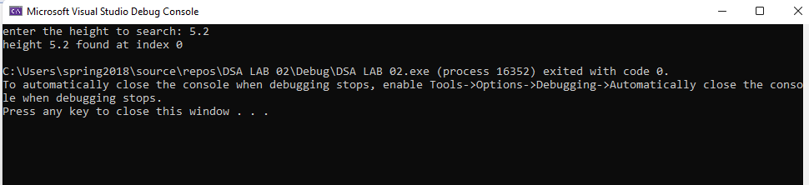

Exercise 2: Gem Hunt in a Treasure Chest

Welcome to the mystical realm of GemQuest! In this enchanting adventure, you are presented with the opportunity to embark on a gem hunt within the legendary treasure chest known as "GemChest." .The GemChest is said to hold a plethora of magical gems, each possessing unique properties. Begin your quest by visualizing the GemChest, a mystical container filled with dazzling gems(like Sapphire, ruby, diamond, emerald etc.). Ask the player to discover the
number of occurrences of their chosen gem within the mystical GemChest. If found then display its occurrence count otherwise display not found. Write a C++ program for the above mystical GemChest.
CODE:
//saba shahid
//02-123421-048
// CS 3-A

#include <iostream>
#include <string>
using namespace std;

int main() {

string gemChest[] = { "Sapphire", "Ruby", "Diamond", "Emerald", "Topaz","Ruby", "Amethyst", "Sapphire", "Opal", "Diamond","Emerald", "Sapphire", "Pearl", "Ruby", "Aquamarine" };

int size = sizeof(gemChest) / sizeof(gemChest[0]);
string searchGem;
int count = 0;

cout << "enter the name of the gem you want to search "<< endl;
getline(cin, searchGem);

for (int i = 0; i < size; i++) {
if (gemChest[i] == searchGem) {
count++;
}
}

if (count > 0) {
cout << "The mystical gem" << searchGem << "is found " << count << " times! :D" << endl;
}
else {
cout << "The gem " << searchGem << "' was not found :( Keep searching! :3" << endl;
}

return 0;
}

OUTPUT:
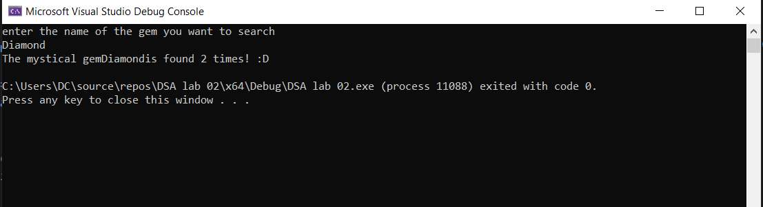

Exercise 3: Search in FlavorRush’s menu

You have been assigned the task of creating a menu search feature for a popular fast food chain FlavorRush. With around 15 popular items on the menu, such as burgers, sides, and beverages, the goal is to allow customers to easily search for specific menu items and receive feedback on their availability. If an item is found, display item found with its locations and if the item isn’t found, notify the user that it’s not offered.

CODE:

//saba shahid
//02-123421-048
// CS 3-A

#include <iostream>
#include <string>
using namespace std;

struct Menu{
string name;
string category;
double price;
string location;
};

int searchMenu(Menu menu[], int size, string itemName) {
for (int i = 0; i < size; i++) {
if (menu[i].name == itemName)
return i;
}
return -1;
}

int main() {

Menu menu[15] = {
{"Cheese Burger", "Burger", 4.99, "Main Counter, Drive-Thru"},
{"Chicken Burger", "Burger", 5.49, "Main Counter, Drive-Thru"},
{"Veggie Burger", "Burger", 4.79, "Main Counter"},
{"Fries", "Side", 2.99, "Main Counter, Drive-Thru"},
{"Onion Rings", "Side", 3.49, "Main Counter"},
{"Chicken Nuggets", "Side", 3.99, "Main Counter, Drive-Thru"},
{"Mozzarella Sticks", "Side", 4.29, "Main Counter"},
{"Coca Cola", "Beverage", 1.99, "All Locations"},
{"Pepsi", "Beverage", 1.99, "All Locations"},
{"Lemonade", "Beverage", 2.49, "Main Counter"},
{"Iced Tea", "Beverage", 2.29, "Main Counter, Drive-Thru"},
{"Milkshake", "Beverage", 3.99, "Main Counter"},
{"Hot Coffee", "Beverage", 2.99, "Main Counter, Drive-Thru"},
{"Grilled Chicken Wrap", "Wrap", 5.99, "Main Counter, Drive-Thru"},
{"Fish Sandwich", "Burger", 5.49, "Main Counter"}
};
//why wasss there 15 items had to type sm:((((

int size = 15;
string searchItem;

cout << "enter the menu item to search: " << endl;
getline(cin, searchItem);

int index = searchMenu(menu, size, searchItem);

if (index != -1) {
cout << "item Found! :)" << endl;
cout << "name: " << menu[index].name << endl;
cout << "category: " << menu[index].category << endl;
cout << "price: " << menu[index].price << endl;
cout << "vailable at: " << menu[index].location << endl;
}
else {
cout << searchItem << " not found! :(" << endl;
}
return 0;
}

OUTPUT:

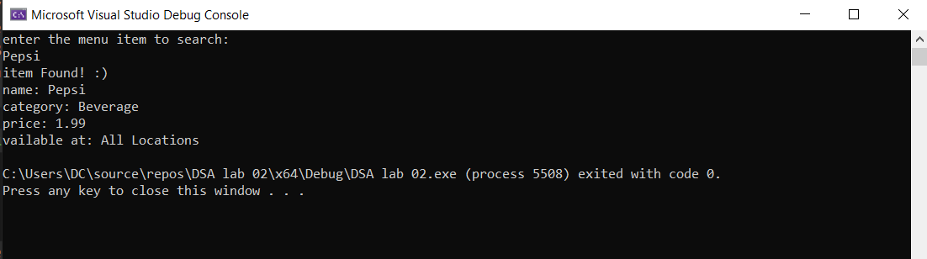

Exercise 4: Searching an item in a website
Superior shopping is an ecommerce website that sells various house hold products to its customers. The website has a vast database of products with their names, descriptions, prices, and other relevant details. The task is to implement a search functionality on the website that allows users to search for products by their prices, name etc. Information of the 20 products are given below.
Write a program in C++ that implements searching functionality as follow.
- Apply Binary Search algorithm to search the product with their price. Display Product id, name,price and position of the product. Display a message “no item found” if the product is not found
- Search the product ”Prod_x” by applying linear search algorithm and display Product id, name,price and position of the product

Product_id | Product_name | Price
001 | Prod_a | 300
006 | Prod_c | 450
005 | Prod_d | 500
010 | Prod_f | 550
045 | Prod_x | 750
012 | Prod_m | 800
034 | Prod_o | 850
002 | Prod_n | 900
008 | Prod_h | 950
019 | Prod_z | 1050
007 | Prod_y | 1100
011 | Prod_aa | 1200
017 | Prod_bb | 1500
003 | Prod_ad | 1600
004 | Prod_ef | 2000
020 | Prod_ij | 2050

031 | Prod_kl | 3000
040 | Prod_mn | 3200
035 | Prod_ik | 3500
022 | Prod_ij | 4000
CODE:
// saba shahid
// 02-134241-048
// CS 3-A
#include <iostream>
using namespace std;

struct Product {
int prod_id;
string prod_name;
double price;
};

int BinarySearch(Product product[], int item, int big, int end) {
while (big <= end) {
int mid = big + (end - big) / 2;
if (product[mid].price == item)
return mid;
else if (product[mid].price < item)
big = mid + 1;
else
end = mid - 1;
}
return -1;
}

int main() {
int size = 20;

Product products[20] = {
{1, "Prod-a", 300}, {6, "Prod-c", 450}, {5, "Prod-d", 500},{10, "Prod-f", 550}, {45, "Prod-x", 750}, {12, "Prod-m", 800}, {34, "Prod-o", 850}, {2, "Prod-n", 900}, {8, "Prod-h", 950},
{19, "Prod-z", 1050}, {7, "Prod-y", 1100}, {11, "Prod-aa", 1200},{17, "Prod-bb", 1500}, {3, "Prod-ad", 1600}, {4, "Prod-ef", 2000},
{20, "Prod-ij", 2050}, {31, "Prod-kl", 3000}, {40, "Prod-mn", 3200},{35, "Prod-ik", 3500}, {22, "Prod-ij", 4000} };

int searchPrice;
cout << "enter price to search: " << endl;
cin >> searchPrice;

int index = BinarySearch(products, searchPrice, 0, size - 1);

//again yahan pr -2 index wont be in array so the code seraches the whole array
if (index != -2) {
cout << "product found at position " << index << endl;
cout << "ID: " << products[index].prod_id << ", name: " << products[index].prod_name<< ", price: " << products[index].price << endl;
}
else {
cout << "no found";
}

return 0;
}
OUTPUT:
